

Western Governors University

**Emerging Technologies in Cybersecurity**

**C844**

**Greg Westmoreland**

**GRP1 Task 1: NMAP AND WIRESHARK**

**A. Network Topology**

A screenshot of running Zenmap:

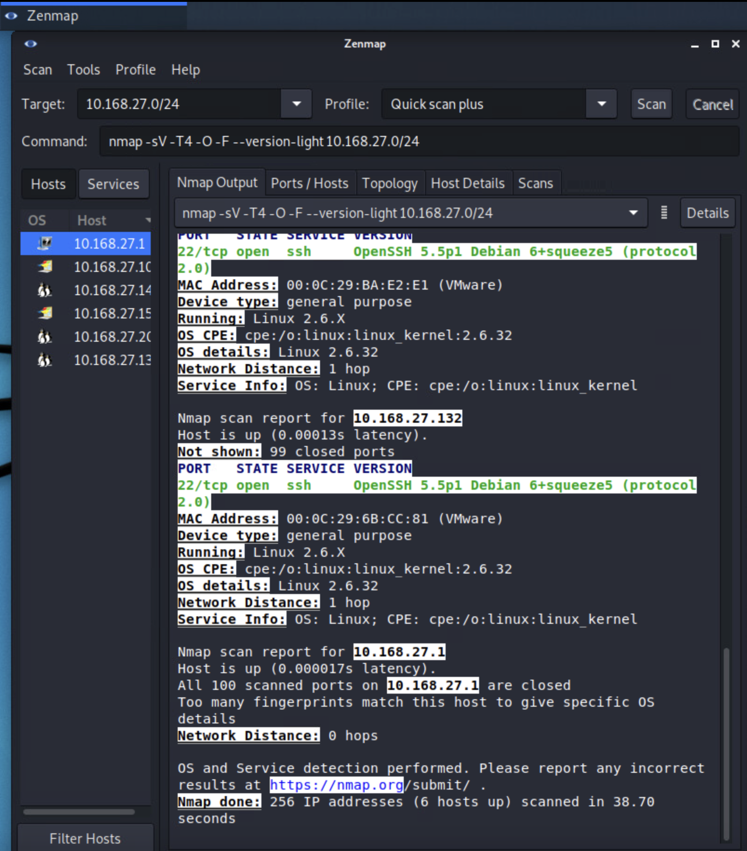

Screenshot of Zenmap Topology:

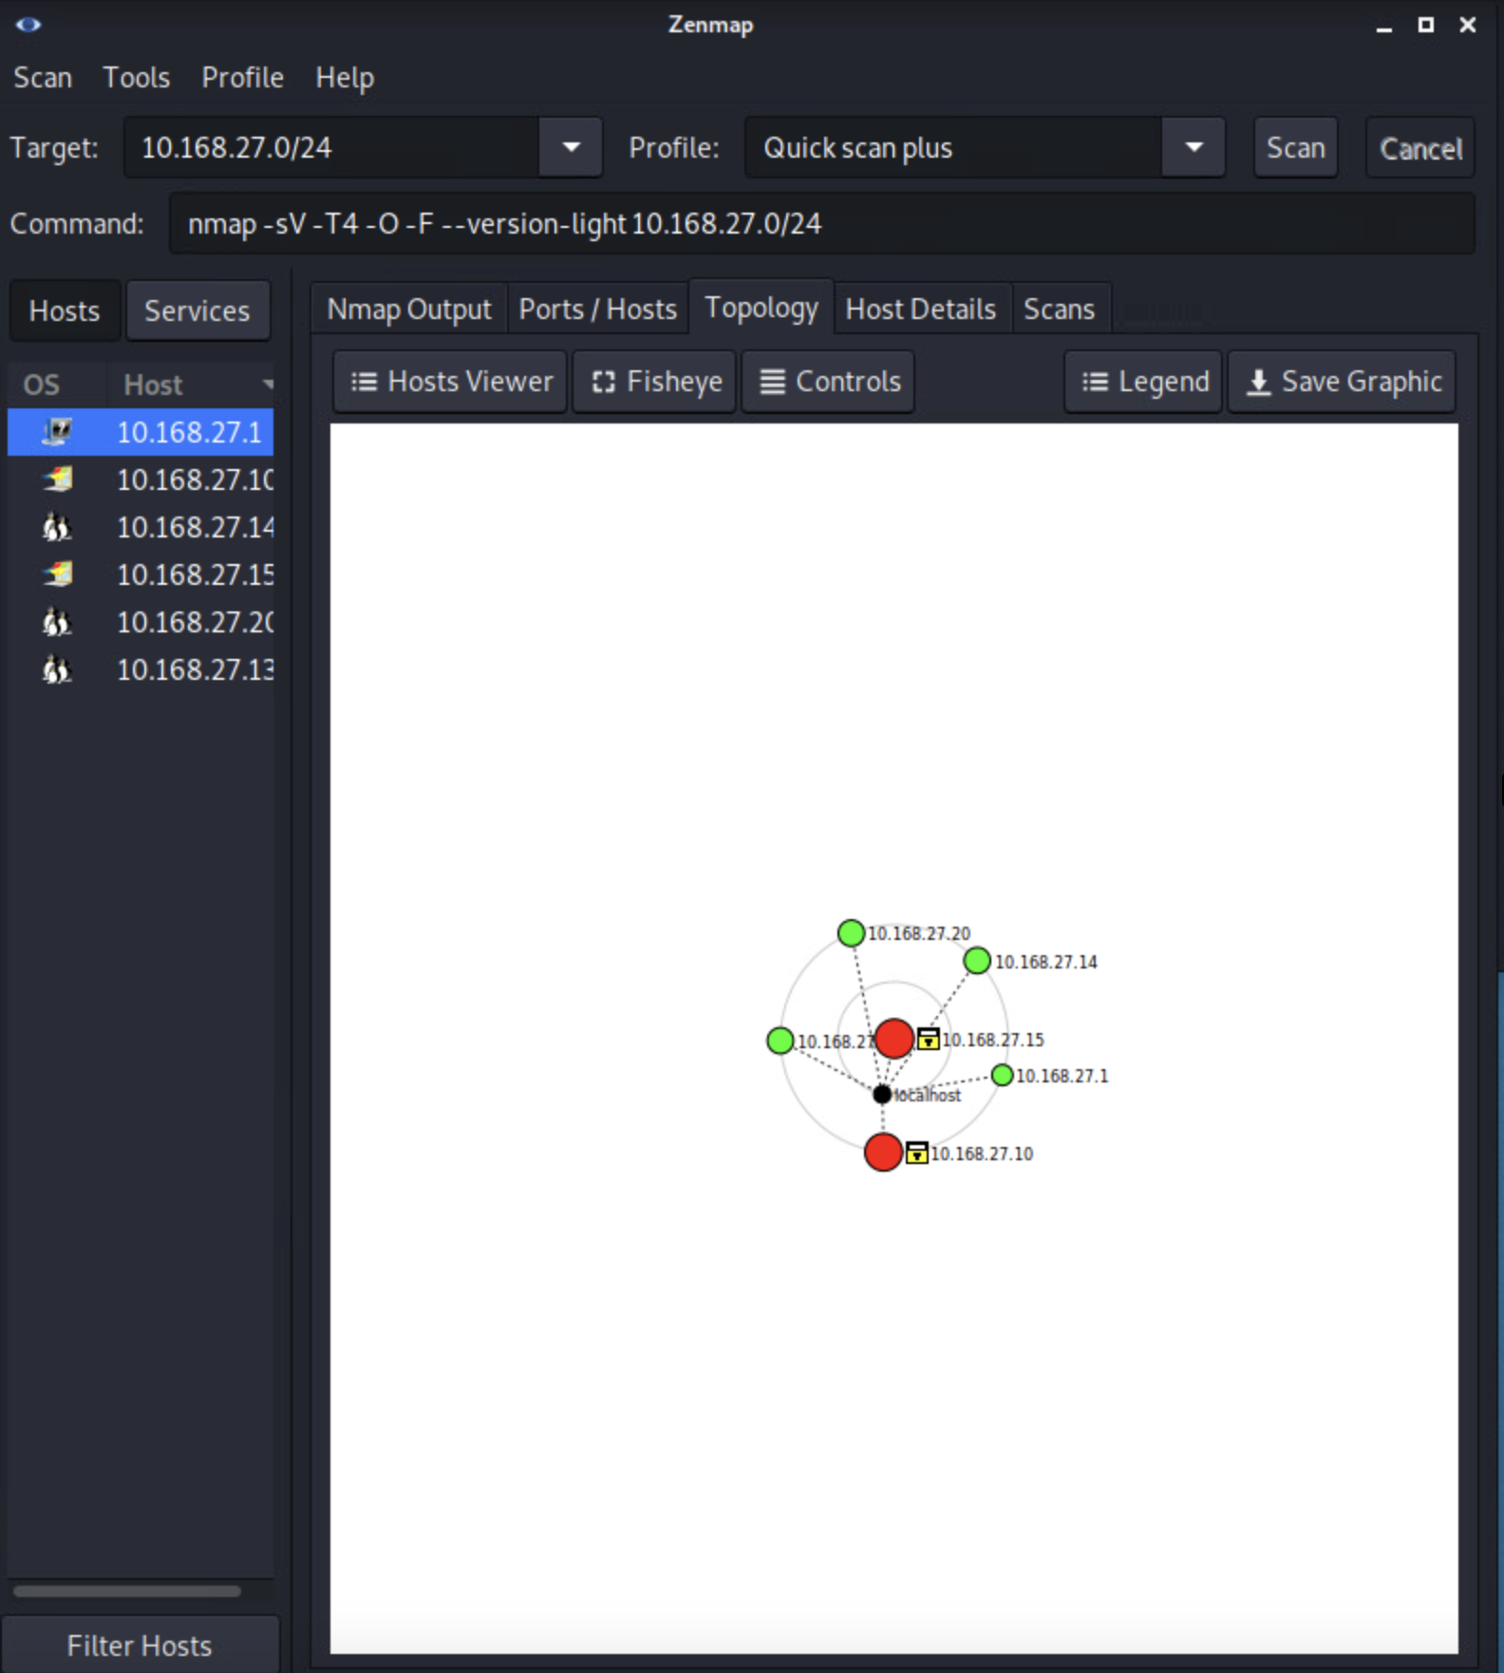

This is a star topology for IP address 10.168.27.0/24. The topology includes 6 nodes:

* One node has IP address 10.168.27.1 with an unknown operating system and 0 open ports.
* Another node has IP address 10.168.27.10 with a Microsoft Windows Server 2012 or Windows Server 2012 R2 operating system and 8 open ports.
* Another node has IP address 10.168.27.14 with a Linux 2.62.32 operating system and 1 open port.
* One node has IP address 10.168.27.15 with a Microsoft Windows 7 Professional or Windows 8 operating system and 10 open ports.
* Another node has IP address 10.168.27.20 with a Linux 2.62.32 operating system and 1 open port.
* Another node has IP address 10.168.27.132 with a Linux 2.62.32 operating system and 1 open port.

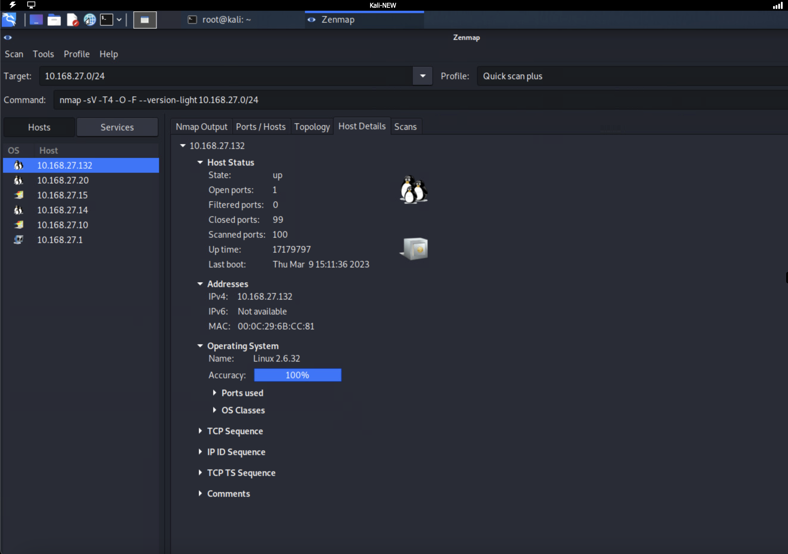

**B Summary of Vulnerabilities and Implications**

**First vulnerability**

The first vulnerability identified with Zenmap on node 10.168.27.14 was OpenSSH 5.5pl Debian 6+squeeze5 (protocol 2.0). One specific common vulnerability and exposure has been documented as a CVE-2010-3686[1]. This CVE is known as an OpenID module in Drupal 6.x before 6.18, and the OpenID module 5.x before 5.x-1.4 for Drupal. If this node is running Drupal 6.x version before 6.18 or Drupal 5.x before 5.x-1.4, this CVE confirms that OpenID 2.0 protocol does not ensure that fields are signed and would allow remote attackers to bypass authentication by leveraging an assertion from an OpenID provider and gain access to the node [1]. Once a node is compromised, it could cause further vulnerable attacks over the network once node 10.168.27.14 has been compromised.

**Second vulnerability**

The second vulnerability identified with Zenmap on node 10.168.27.15 was Microsoft IIS httpd version 8.5. One specific common vulnerability and exposure has been documented as a CVE-2014-4078[2]. This CVE is known as an IP Security feature in Microsoft Internet Information Services (IIS) 8.0 and 8.5 that does not properly process wildcard allow and deny rules for domains within the "IP Address and Domain Restrictions" list. This vulnerability makes it easier for remote attackers to bypass an intended rule set via an HTTP request, aka "IIS Security Feature Bypass Vulnerability", and gain access to the node [2]. Once a node is compromised, it could cause further vulnerable attacks over the network once node 10.168.27.15 has been compromised.

**Third vulnerability**

The third vulnerability identified with Zenmap on node 10.168.27.10 was Microsoft-ds Microsoft Windows Server 2008 R2 - 2012 Microsoft-ds. One specific common vulnerability and exposure has been documented as CVE-2018-8415[3]. This CVE is known as a tampering vulnerability that exists in PowerShell. This vulnerability could allow an attacker to execute unlogged code, aka "Microsoft PowerShell Tampering Vulnerability." This CVE is known to affect Windows 7, PowerShell Core 6.1, Windows Server 2012 R2, Windows RT 8.1, PowerShell Core 6.0, Windows Server 2019, Windows Server 2012, Windows 8.1, Windows Server 2016, Windows Server 2008 R2, Windows 10, Windows 10 Servers [3].

**C. Wireshark Anomalies**

**First Anomaly**

The first anomaly that was noticed from the Pcap1.pcapng file of captured packets with Wireshark, and the range of packets, was from the MySQL protocol. These “Request [Malformed Packets]” could be an attack from source IP 10.16.80.243 using malformed packets as an attack to gain access to node 10.168.27.10. If the node is using MySQL version 5.0.45, attackers can cause a denial of service (daemon crash) via a malformed password packet in the connection protocol [4]. This attack is a common vulnerability and exposure has been documented as CVE-2007-3780[4].

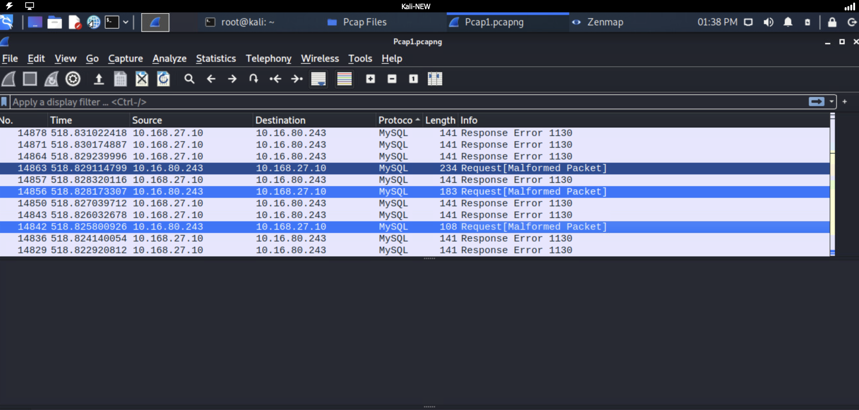

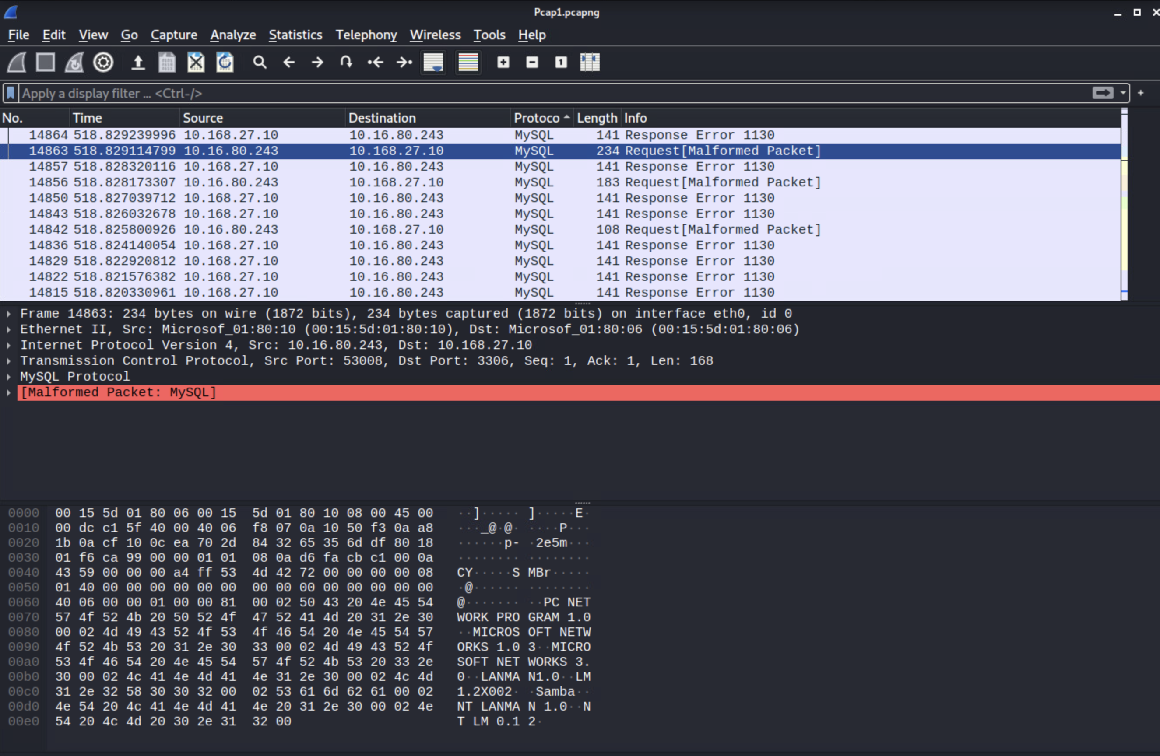

**Second Anomaly**

The second anomaly that was noticed from the Pcap1.pcapng file of captured packets with Wireshark, and the range of packets, was from the ICMP protocol. These “Destination Unreachable (Port Unreachable)” could be an attack from source IP 10.16.80.243 using a vulnerability known as “ICMPv6 Vulnerability” toward node 10.168.27.10. The TCP/IP implementation in Microsoft Windows Vista SP2, Windows Server 2008 SP2 and R2 SP1, Windows 7 SP1, Windows 8, Windows Server 2012, and Windows RT does not properly perform memory allocation for inbound ICMPv6 packets [5]. This can allow remote attackers to cause a denial of service (system hang) via crafted packets. This common vulnerability and exposure have been documented as CVE-2013-3183[5].

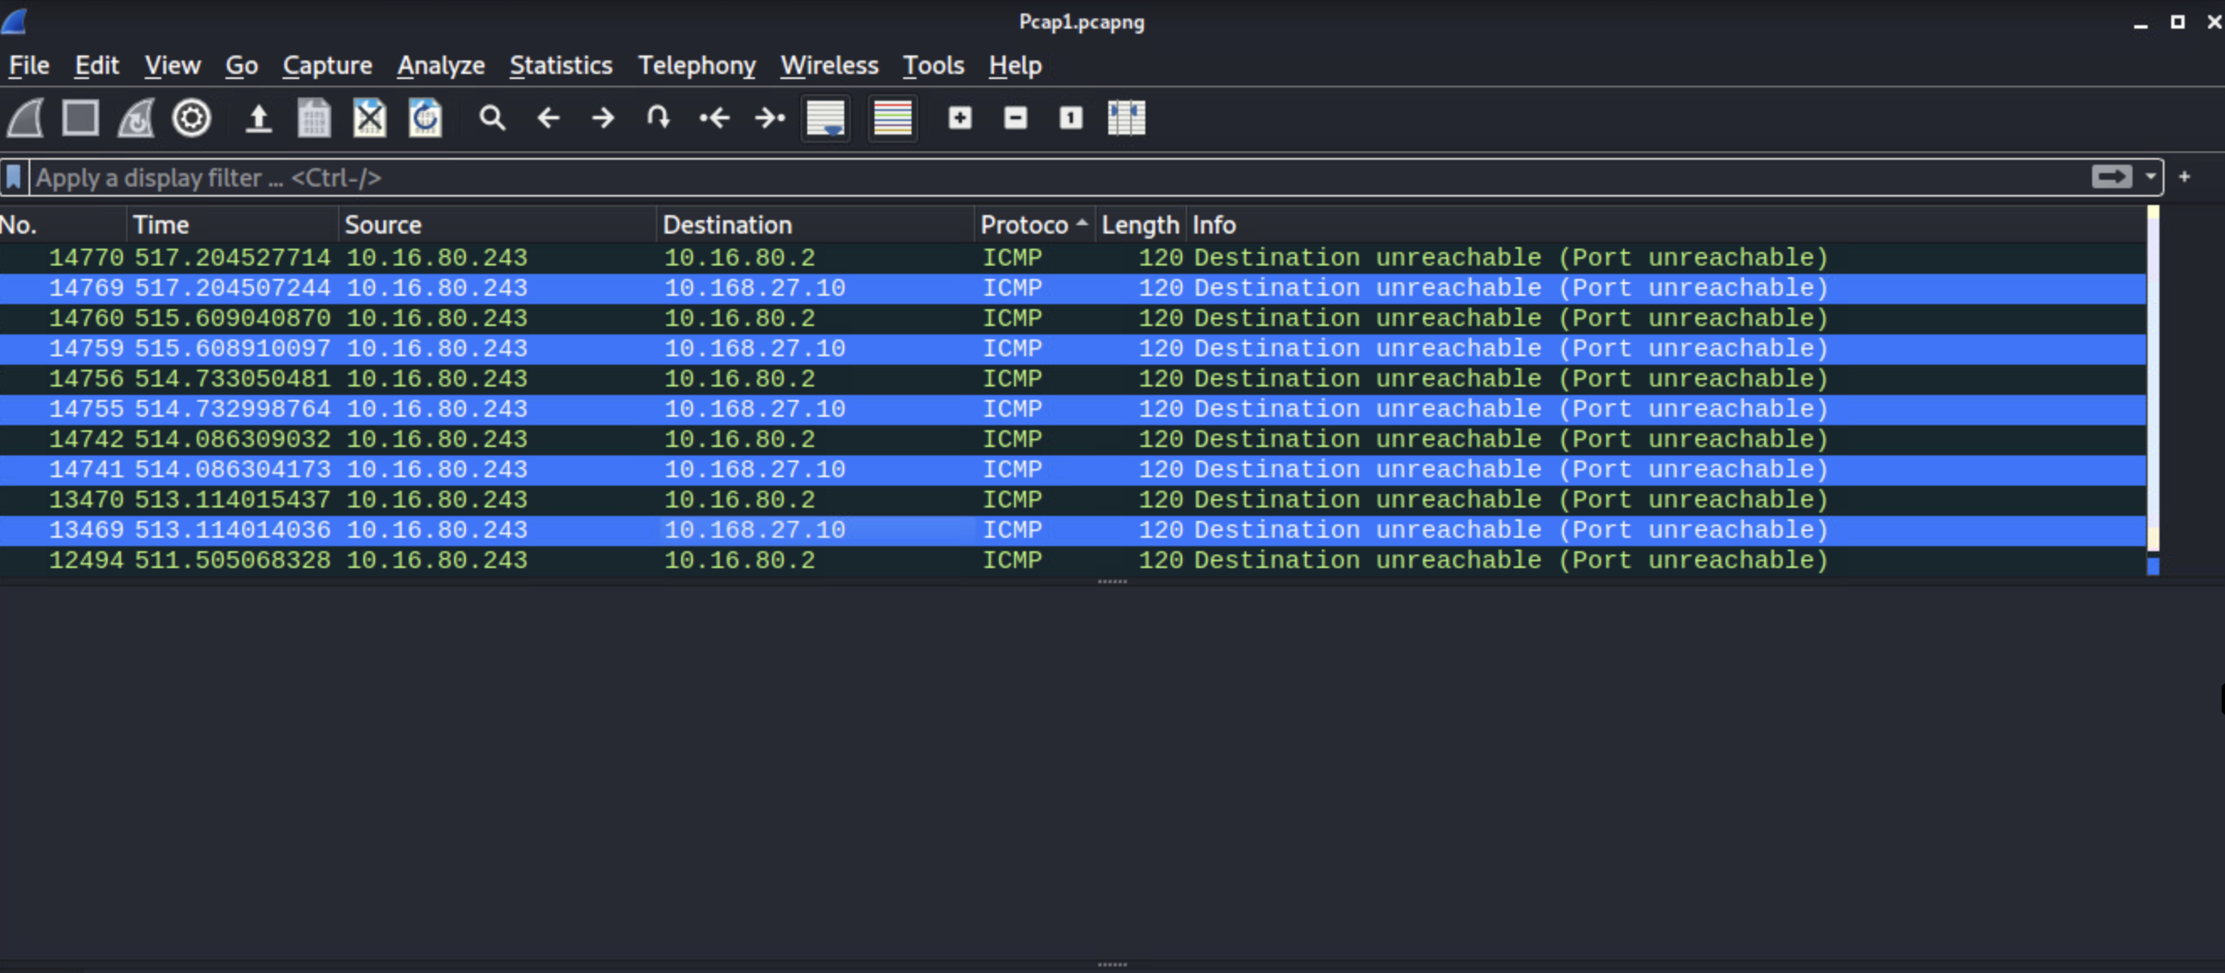

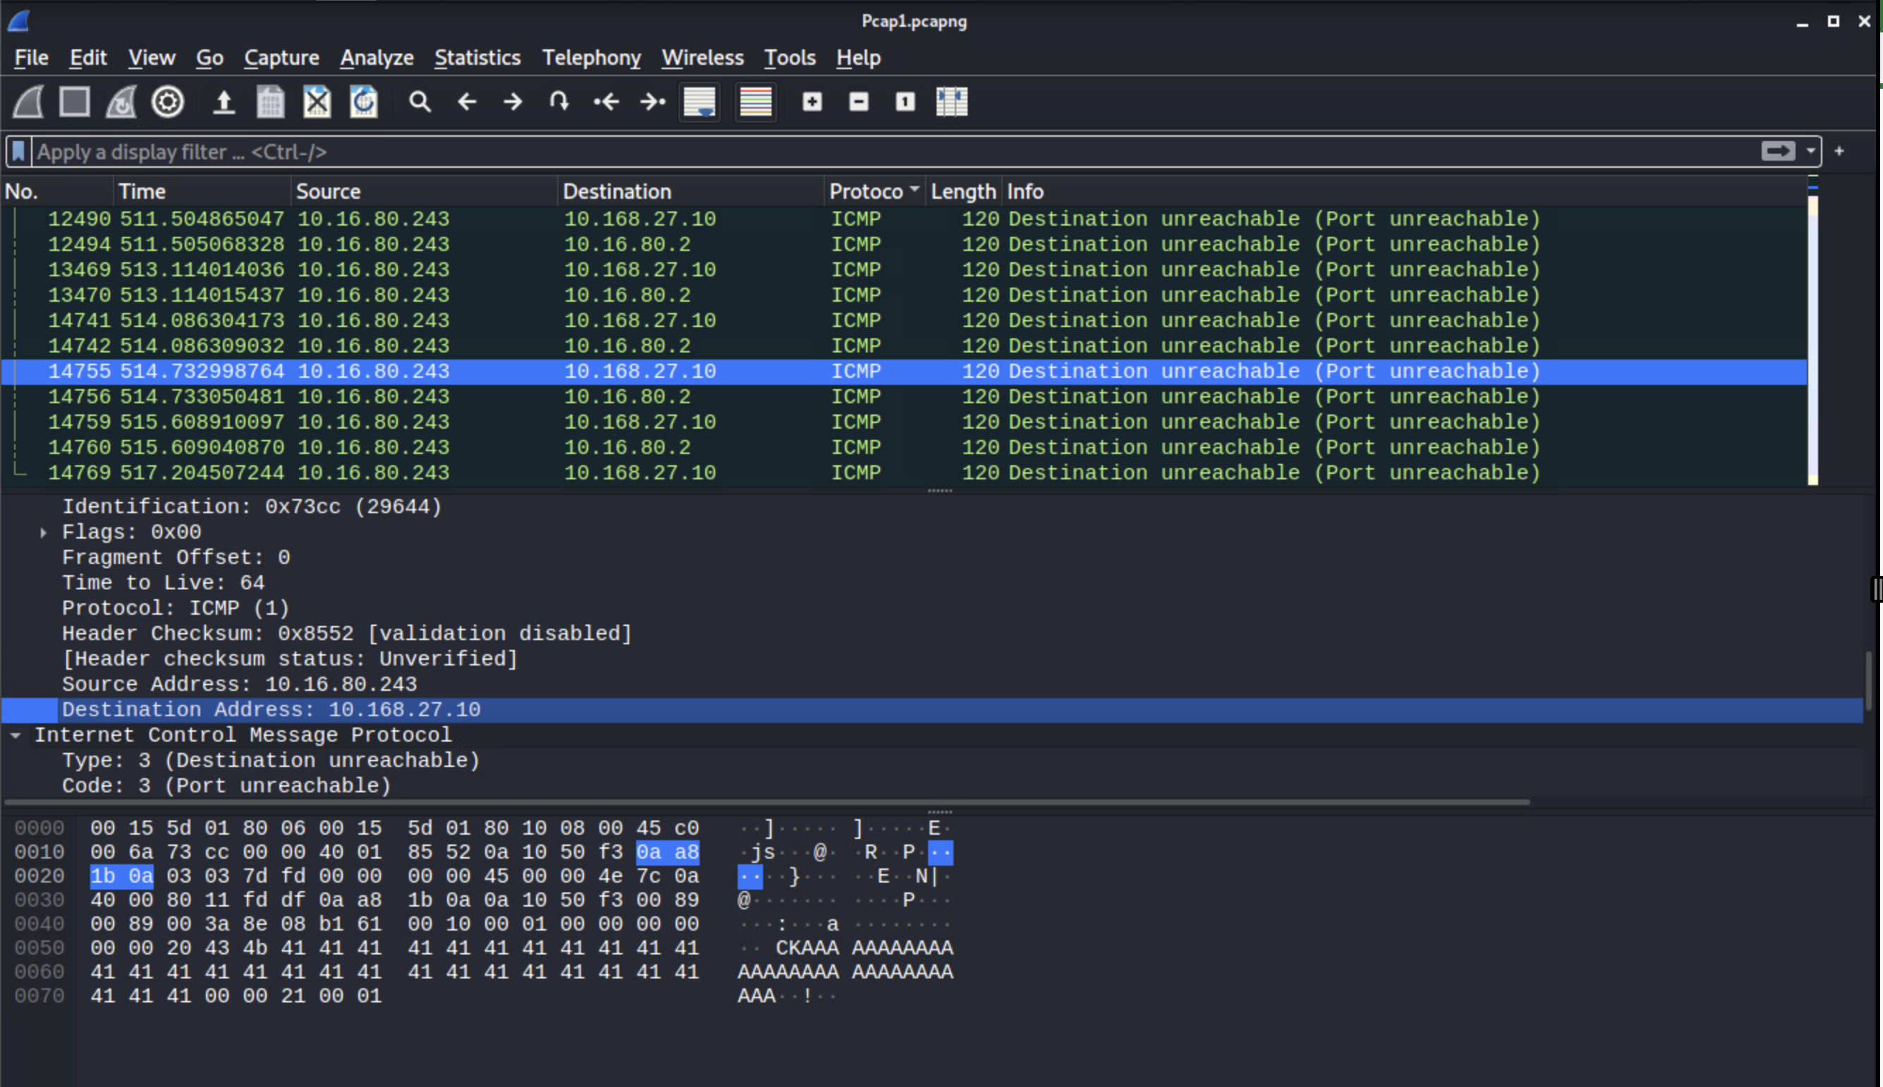

**Third Anomaly**

The second anomaly that was noticed from the Pcap1.pcapng file of captured packets with Wireshark, and the range of packets, was from the HTTP protocol. These “404 Not Found” and “405 Method Not Allowed” could be an attack from source IP 10.16.80.243 using a vulnerability toward node 10.168.27.10. If the destination node is using Microsoft Windows IIS 5.0 or 5.1, this version supports WebDAV methods which could allow remote attackers to determine the internal IP address of the system (which may be obscured by NAT) via (1) a PROPFIND HTTP request with a blank Host header, which leaks the address in an HREF property in a 207 Multi-Status response, or (2) via the WRITE or MKCOL method, which leaks the IP in the Location server header[6]. This common vulnerability and exposure have been documented as CVE-2002-0422[6].

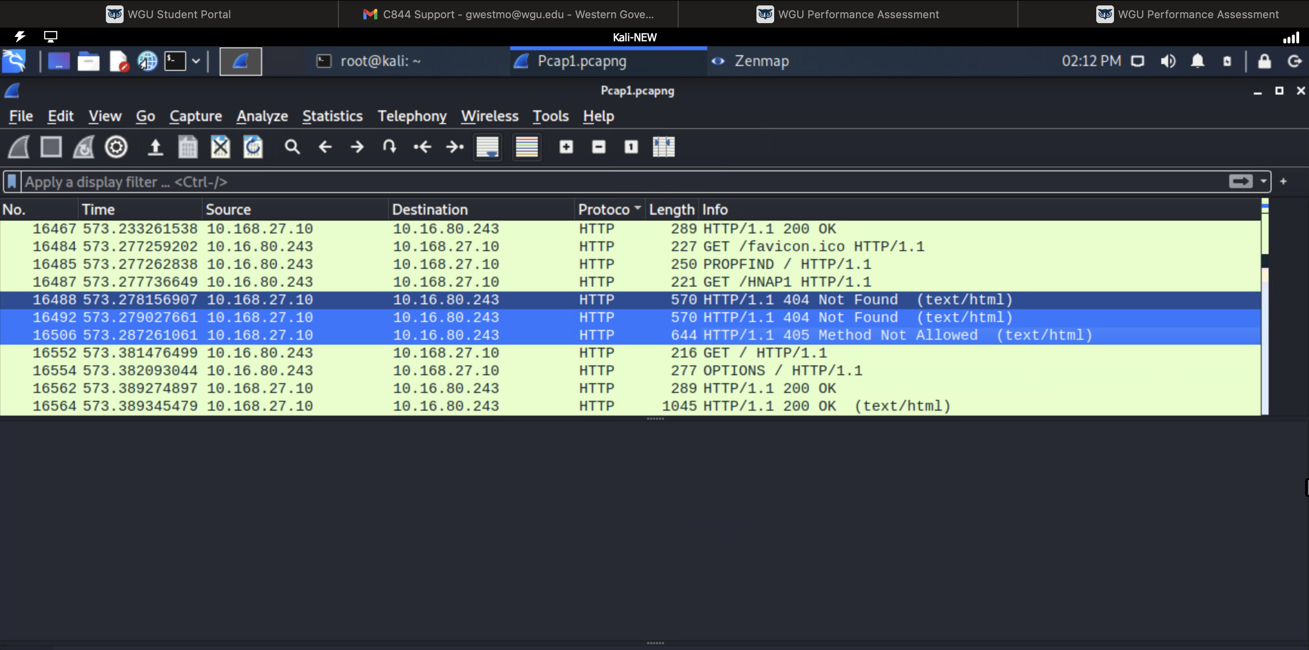

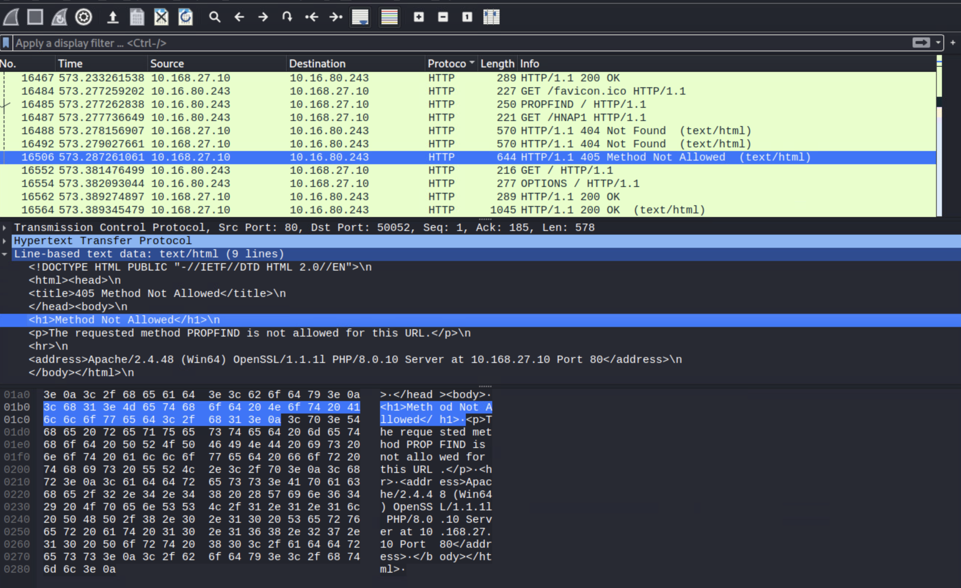

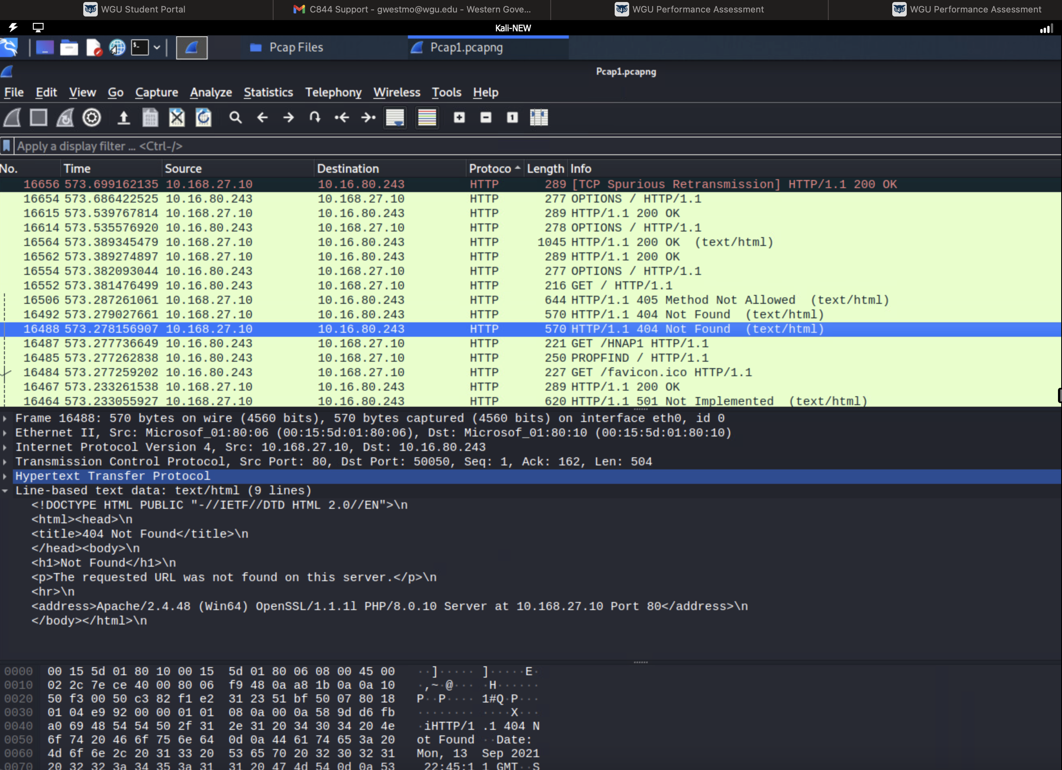

**D. Implications of each Wireshark Anomaly**

**The implications of taking no action for anomaly number 1:**

If CVE-2007-3780 is ignored or not dealt with in a timely manner, this could lead to a DoS, Denial of Service for the MySQL database that is being targeted on node 10.168.27.10. With the database being under attack, it could potentially render the database useless for legitimate requests from other nodes on the network. This could cause financial loss and reputable damage if the database is locked up due to illegitimate requests coming through the DoS.

**The implications of taking no action for anomaly number 2:**

If CVE-2013-3183 is ignored or not dealt with in a timely manner, this could cause a Denial of Service (DoS) potentially causing the Windows Server to become unresponsive or crash. Once the server has been brought down, it could cause service disruption for other nodes dependent upon it over the network. This could cause financial loss and reputable damage if the server is taken offline due to illegitimate requests coming through the DoS.

**The implications of taking no action for anomaly number 3:**

If CVE-2002-0422 is ignored or not dealt with in a timely manner, this could allow an attacker to be able to determine the internal IP address of the Windows system which is obscured by Network Address Translation. If the attacker were able to determine the internal IP, the attacker would be able to gain very important information about the server's network layout and topology. This knowledge could potentially help them strategize and determine the locations of other nodes as potential targets.

**E. Recommended Solutions**

**First Vulnerability**

To mitigate CVE-2010-3686, it is recommended to upgrade the Drupal version to Drupal 6.18 or 6.19 if node 10.168.27.14 is running Drupal 6.x. If the 10.168.27.14 node is running Drupal 5.x, the recommendation would be to upgrade to Drupal 5.23[7].

**Second Vulnerability**

To mitigate CVE-2014-4078, it is recommended to apply Windows Security Update for Windows 8 for x64-based Systems (KB2982998)[8] that is recommended on Microsoft Security Bulletin MS14-076[9].

**Third Vulnerability**

To mitigate CVE-2018-8415, it is recommended to apply Windows 2018-11 Security Monthly Quality Rollup for Windows Server 2012 for x64-based Systems (KB4467701)[10] that is recommended on Microsoft PowerShell Tampering Vulnerability[11].

**First Anomaly**

To mitigate CVE-2007-3780, it is recommended to apply a patch[12] for MySQL version 5.0.45 to dev.mysql.com.

**Second Anomaly**

To mitigate CVE-2013-3183, it is recommended to apply the Windows security patch mentioned for Windows Server 2012 on Microsoft Security Bulletin MS13-065 - Important Vulnerability in ICMPv6 could allow Denial of Service (2868623)[13].

**Third Anomaly**

To mitigate CVE-2002-0422, it is recommended to run the following commands on the command prompt:

* adsutil set w3svc/UseHostName True
* net stop iisadmin /y
* net start w3svc

These commands will cause the IIS server to use the machine's hostname rather than its IP address [14]. The other recommendation is to upgrade the Microsoft IIS 5.0 or 5.1 version to a higher version number such as Windows IIS 6.0 which addresses older version vulnerabilities with “one of the most important changes in IIS 6.0 addresses Web server security.” [15]

**References**

1. “CVE-2010-3686” <https://cve.mitre.org/cgi-bin/cvename.cgi?name=CVE-2010-3686> September 24, 2023.
2. “CVE-2014-4078” <https://cve.mitre.org/cgi-bin/cvename.cgi?name=CVE-2014-4078> September 24, 2023.
3. “CVE-2018-8415” <https://cve.mitre.org/cgi-bin/cvename.cgi?name=CVE-2018-8415> September 24, 2023.
4. “CVE-2007-3780” <https://cve.mitre.org/cgi-bin/cvename.cgi?name=CVE-2007-3780> September 24, 2023.
5. “CVE-2013-3183” <https://cve.mitre.org/cgi-bin/cvename.cgi?name=CVE-2013-3183> September 24, 2023.
6. “CVE-2002-0422” <https://cve.mitre.org/cgi-bin/cvename.cgi?name=CVE-2002-0422> September 24, 2023.
7. “SA-CORE-2010-002 - Drupal core - Multiple vulnerabilities” <https://www.drupal.org/node/880476> September 24, 2023.
8. “Security Update for Windows 8 for x64-based Systems (KB2982998)” <https://www.microsoft.com/en-us/download/details.aspx?id=44807> September 24, 2023.
9. "Microsoft Security Bulletin MS14-076 - Important" <https://learn.microsoft.com/en-us/security-updates/securitybulletins/2014/ms14-076> November 11, 2014.
10. "Microsoft Catalog Update" <https://catalog.update.microsoft.com/Search.aspx?q=KB4467701> November 13, 2018.
11. "Microsoft PowerShell Tampering Vulnerability" <https://msrc.microsoft.com/update-guide/vulnerability/CVE-2018-8415> November 13, 2018.
12. "CVE-2007-3780" <https://feedly.com/cve/CVE-2007-3780> July 15, 2007.
13. "Microsoft Security Bulletin MS13-065 - Important Vulnerability in ICMPv6 could allow Denial of Service (2868623)" <https://learn.microsoft.com/en-us/security-updates/securitybulletins/2013/ms13-065> August 13, 2003.
14. "IIS Internal IP Address Disclosure (#NISR05032002B)" <https://seclists.org/bugtraq/2002/Mar/101> March 5, 2002.
15. "Version Differences in IIS Administration Features" <https://learn.microsoft.com/en-us/previous-versions/iis/6.0-sdk/ms524539(v=vs.90)> June 16, 2017.